Chapter 9: Straight line graphs
Worksheet A

- For the rule y = -2x + 1, complete the following table of values and then plot and draw a graph on the axes provided.

x | -3 | -2 | -1 | 0 | 1 | 2 | 3
y

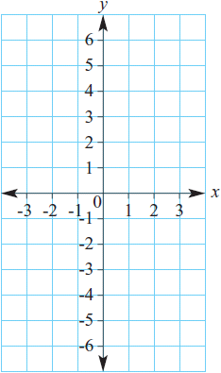

2
a Does the point (-2, 1) lie on the graph of y = 3x – 5?

____________________________________________________________________________________

____________________________________________________________________________________

b Does the point (6, -4) lie on the graph of y =8 – 2x?

____________________________________________________________________________________

_______________________________________________________________________________________________

3 Find the rule for these tables of values.

a
x | -2 | -1 | 0 | 1 | 2
y | -9 | -5 | -1 | 3 | 7

b
x | 3 | 4 | 5 | 6 | 7
y | -2 | -4 | -6 | -8 | -10

